Western Bat Programmatic Biological Opinion (PBO) and Programmatic Conference Opinion (PCO) for the following bat species: Indiana bat (Myotis sodalis, MYSO), gray bat (M. grisescens, MYGR), northern long-eared bat (M. septentrionalis, MYSE), tricolored bat (Perimyotis subflavus, PESU), and little brown bat (M. lucifugus, MYLU)
link to Programmatic Biological Opinion https://connect.ncdot.gov/resources/Environmental/EAU/BSG/Documents/Bats/Bat%20Programmatic%20(Div%209-14)/WNC%20Bats%20PBO%20Div%209-14%20(2025).pdf

PROCESS FOR USING WESTERN BAT PBO:
ECAP or Division Environmental Staff will provide the following information to BSG

As of April 2025, BSG is has created a map of the protective buffer areas and is streamlining this process into an interactive online map and online submission form. But in the meantime, if you have a project you would like to use the western bat PBO, please fill in the information below and email it back to clknepp@ncdot.gov so BSG can track all projects used in PBO and then submit them to USFWS. The below notification process will typically begin when the permit drawings are requested so project construction questions can be answered. However, BSG should also be made aware of these projects at the scoping phase to ensure the survey requirement of the PBO is being fulfilled.

Project-Level Pre Notification
NCDOT Biological Surveys Group will monitor project implementation to ensure all identified conservation measures are implemented, ensure the appropriateness of the opinion’s application, and track take. For each project conducted under this PBO, the NCDOT project manager will work with their project’s environmental lead to provide BSG with the following information prior to any ground-disturbing actions:

Step 1:
- Create a project in IPaC including project boundary and make the following people members: clknepp@ncdot.gov, cdmanley@ncdot.gov, mrmiller2@ncdot.gov, holland_youngman@fws.gov, mark_endries@fws.gov
Step 2: at the time permit drawings are being requested, email clknepp@ncdot.gov the following information to submit to USFWS:
- Description (include basic project description, project timeline (let and timing of construction, if known) and specifics of any structure work that will occur – i.e. bridge rehab, culvert extension, # of structures this work will occur on):
- Location (lat/long decimal degrees):
- Lead Federal Agency: FHWA or USACE
- IPaC generated bat species:
- IPaC generated list date:
- Tree clearing estimate (acres):
- Tree clearing period (months range, if known, example November 2025-May 2026, if unknown, write unknown and we’ll assume worst case):
- Structure work known (rehabilitation, structure removal, how many structures or NA if none):
- Structure work period (months range, if known, example November 2025-May 2026, if unknown, write unknown and we’ll assume worst case):
- Will the project have effects to other listed species that require consultation that will be addressed separately? Yes/No (if yes, list species)
- Can all pertinent CMs be adhered to, see PBO User Key link below, (you may be able to ignore ‘buffer’ CMs if you are not within a Protective Buffer area): Yes/No
https://connect.ncdot.gov/resources/Environmental/EAU/BSG/Documents/Bats/Bat%20Programmatic%20(Div%209-14)/WNC%20Bats%20PBO%20User%20Key.pdf
- Findings of any bat survey work conducted in relation to the covered project, including documents such as completed structure survey forms, photographs, etc. (BSG should have this if everything was turned in to us to enter in the database)

Language for Environmental Documents and Commitments:

For NRTR Documentation for projects in Divisions 9-14, we typically do not produce a Biological Conclusion (BC) at this time not knowing what construction activities will occur. It is our protocol to show a BC of Unresolved until we get closer to project permitting and can determine impacts and develop a biological conclusion for listed animal species. The blurb below is appropriate for this stage of project planning.

Biological Conclusion: Unresolved
As of [Date], the following federally protected bat species are listed in IPaC (https://ecos.fws.gov/ipac/) as occurring in the action area: [list of species in IPaC]. Construction activities for this project are unknown at this stage in project planning, NCDOT will resolve Section 7 prior to let as appropriate.

To be included in NEPA Documentation for projects in Divisions 9-14 there will be 2 scenario stages your project could be in, this first paragraph is standard and will be included in both scenarios, however, the second paragraph will differ based on the project stage (red text: further coordinate with BSG to determine project eligibility, starting in 2025, BSG has begun to proactively include the projects’ eligibility for PBO use in the Bat Survey Memos on ETRACS):
The U.S. Fish and Wildlife Service (USFWS), in partnership with the Federal Highway Administration (FHWA), U.S. Army Corps of Engineers (USACE), and NCDOT, has issued a combined Programmatic Biological Opinion (PBO) and Programmatic Conference Opinion (PCO) for the following bat species: Indiana bat (Myotis sodalis, MYSO), gray bat (M. grisescens, MYGR), northern long-eared bat (M. septentrionalis, MYSE), tricolored bat (Perimyotis subflavus, PESU), and little brown bat (M. lucifugus, MYLU). Per current design and construction plans, the project is eligible for PBO use, provided NCDOT can adhere to the appropriate Conservation Measures outlined in the PBO/PCO.

Scenario Stage 1: If the Biological Conclusion is unknown (red text will change per project):
The proposed biological conclusion for bats is unknown at this stage in project planning and will be rendered prior to let as appropriate. The PBO will ensure compliance with Section 7 of the Endangered Species Act for five years (effective through April 1, 2030) for all NCDOT projects with a federal nexus in Divisions 9-14, which includes XXXX County, where TIP is located.

Scenario Stage 2: The BC is known and NCDOT has received the prenotification confirmation letter from USFWS (red text will change per project):
The USFWS, Asheville Ecological Services Field Office reviewed this project for coverage under the PBO/PCO issued April 1, 2025. In a letter dated July 7, 2025, USFWS confirmed the project meets the criteria for coverage under this PBO in accordance with section 7 of the Endangered Species Act of 1973, as amended (16 U.S.C. 1531– 1543) (ESA), thus concluding consultation for the project for tricolored bat, northern Long-eared bat, and gray bat. The PBO will ensure compliance with Section 7 of the Endangered Species Act for five years (effective through April 1, 2030) for all NCDOT projects with a federal nexus in Divisions 9-14, which includes XXXX County, where TIP is located.

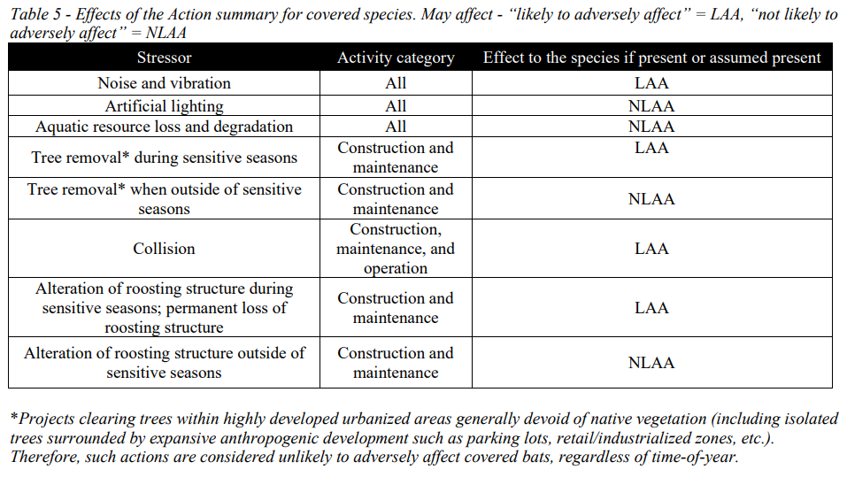

Green Sheet Commitments for projects using western bat programmatic:
In an effort to streamline green sheet commitments and contract language for the projects that utilize the Western North Carolina Bat Programmatic Agreement, the Department will only include certain commitments that involve protected buffers and the reporting requirement. Standard Best Management Practices that are listed as conservation measures in permits will no longer be included in the green sheets or contracts/notes on plans. Please use the following language in contracts to maintain consistency throughout the Department. The first three are only for projects that are in the protected buffered areas, it is very important that people understand not to copy and paste these first 3 for all bat PBO projects. If your project is within a buffered area, enter all of the below, if not, just enter the last two.

If a project is within a protective buffer, as identified by the NCDOT Biological Surveys Group, the following conservation measures shall be adhered to as written in the Western North Carolina Bat Programmatic Agreement (Service log #22-244), and entered as a project commitment as follows:

Title: Tree Cutting Restrictions
Commitment: Limit tree clearing within 100 meters (328 ft) of blue line streams on USGS topographic maps. The following exceptions apply within 10 meters of a stream: (1) the NCDOT must clear easements (utility, drainage, and construction), (2) at bridge sites, the NCDOT must clear the entire width of the right of way beginning at a station three feet beyond the beginning and ending extremity of the structure, per NCDOT Standard Specifications.
Reason: Per Western North Carolina Bat Programmatic Agreement (Service log #22-244)
Commit. Type: One Time
Phase: Construction
Stakeholder: USFWS, BSG
Validation: EAU-ECAP or Division Environmental staff
Fulfillment: Division Office

Title: Percussive Activities
Commitment: To the maximum extent possible, if suitable roost trees or structures are present near high-decibel percussive activities (81-162 dBA as measured from 50 feet from source), those percussive activities will be avoided from May 1 – July 31, when non-volant pups may be present.
Reason: Per Western North Carolina Bat Programmatic Agreement (Service log #22-244)
Commit. Type: One Time
Phase: Construction
Stakeholder: USFWS, BSG
Validation: EAU-ECAP or Division Environmental staff
Fulfillment: Division Office

Title: Permanent Lighting
Commitment: Design permanent lighting systems for an average illumination level of 0.6 footcandle, reducing overall brightness, a 25% minimization from a standard 0.8 fc illumination
Reason: Per Western North Carolina Bat Programmatic Agreement (Service log #22-244)
Commit. Type: One Time
Phase: Construction
Stakeholder: USFWS, BSG
Validation: Roadway Design Unit - Lighting and Electrical Team Lead
Fulfillment: Division Office

If using the PBO (regardless of buffer status), enter in project commitment tracker as follows):

Title: Riparian area restoration
Commitment: Replant riparian areas with native, fast-growing tree and shrub species such as American sycamore (Platanus occidentalis), river birch (Betula nigra), silky dogwood (Cornus amomum), and black willow (Salix nigra) where vegetation has been removed. Riparian plantings will not occur in utility, drainage, and construction easements. If excess property is available outside normal maintenance limits at bridge locations, riparian plantings will be installed where safety requirements allow.
Reason: Per Western North Carolina Bat Programmatic Agreement (Service log #22-244)
Commit. Type: One Time
Phase: Construction
Stakeholder: USFWS, BSG
Validation: Roadside Environmental Unit
Fulfillment: Roadside Environmental Unit

Title: Tree Clearing and/or structure removal reporting
Commitment: For each project involving tree clearing or structure removal, submit final numbers of tree clearing and/or number of structures demolished and the date(s) that these activities actually occurred. This will ensure accurate payments and submittal to USFWS in the required annual report. Numbers must be reported using the link to the PBO Reporting Requirement Form on the Biological Surveys Group (BSG) Connect site here https://forms.cloud.microsoft/g/iiEeEtHFU4.
Reason: Per Western North Carolina Bat Programmatic Agreement (Service log #22-244)
Commit. Type: One Time
Phase: Construction
Stakeholder: USFWS, BSG
Validation: EAU-ECAP or Division Environmental staff
Fulfillment: Division Office

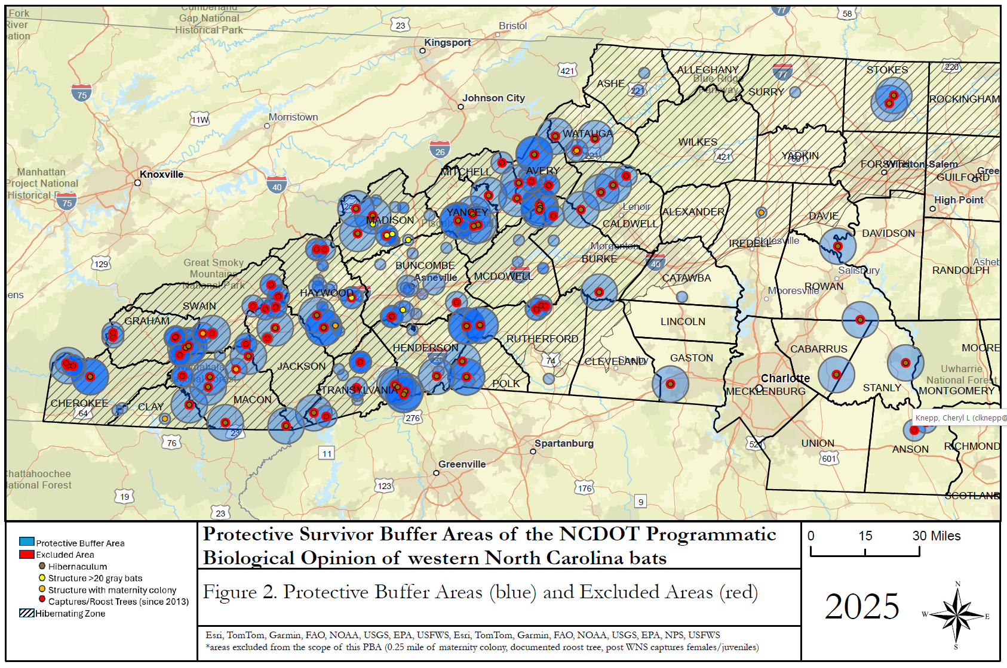
NOTE: For example purposes only, this map will be updated regularly with new bat records, please check with NCDOT BSG

